Applying CSS in ReactJS
1)Inline Styles:-
- Inline css in the same line of an element.
- Here we are using style attribute apply the css.
- CSS property names in camelCase, and the values are the corresponding property values.
App.jsx

import React from 'react'
import { useState } from 'react'
const App = () => {
let [info, setInfo] = useState(
{
name: "sai keerthana",
age: 24,
course:"JAVA FULL STACK"
}
)
return (
<>
<section style={{background:"red",height:"300px",width:"200px",padding:"10px 30px"}}>
<h1 style={{fontSize:"25px",fontWeight:"bolder"}}>Name : {info.name}</h1>
<h2>Course: {info.course}</h2>
<p>Age : {info.age}</p>
</section>
</>
);
}
export default App

2.Module CSS

- If we want to apply css for particular set of components that is present in particular folder inside src.
- Here we have to create separate file for css
- Here CSS file name should have .module.css extension.
filename.module.css
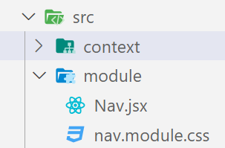
- After creating CSS file in which component, we want we have to import it.

Nav.jsx.
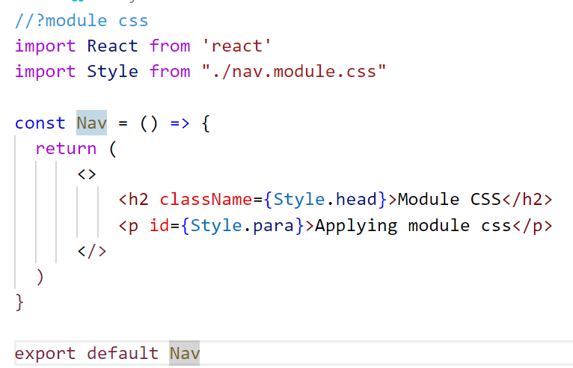
nav.module.css
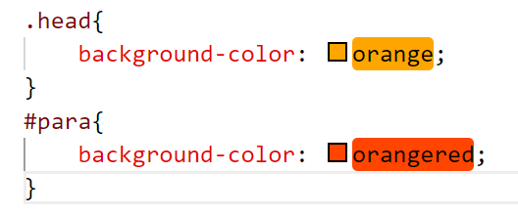
App.jsx
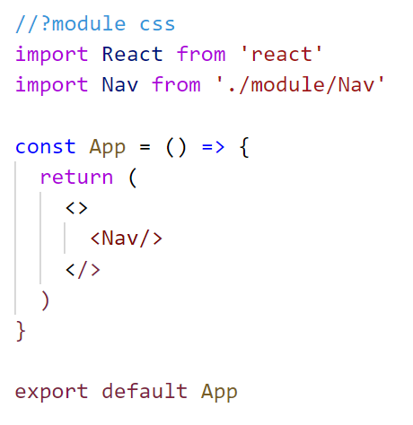
3.Global CSS
- Global css is used to apply css properties to anywhere with in the project for the components.
- Here we have to create separate file for css
- Here CSS file name should have .css extension.
filename.css
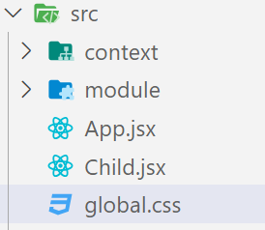
- After creating CSS file import it into entry file i.e index.js
Index.js
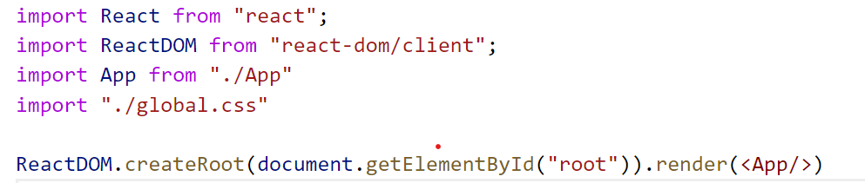
App.jsx
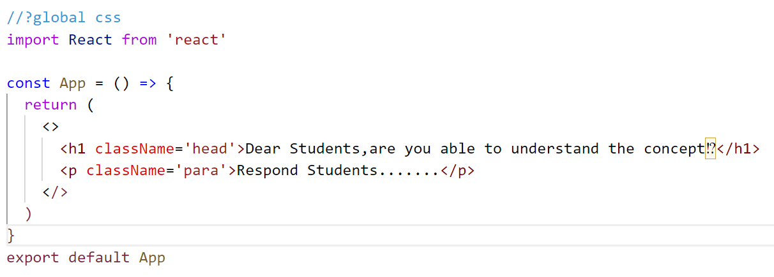

global.css
